**Clone Smartphones**

Moving forward in the copycat series, we spotted the tactics followed by Ambani in Jio apps and SIMs and also spotted the similarities between Airbnb and Desi OYO. This one is about various smartphone clones of the tech giant manufacturers produced by local Indian Startups and manufacturers.

Freedom 251! Yes, you made the right recognition. Well, this was the most promoted and the cheapest Smartphone by Ringing Bells private Ltd., a Noida based startup priced at only 3.54 USD. This Smartphone company started its marketing by showing Apple’s icons and other globally known Smartphone’s screenshot for advertising. There were also various pieces of evidence that the advertisement itself was a scam with a Chinese brand and Apple’s icons used for advertisement by applying whitener over the brand names. Ringing Bells was further accused of fraud and scams. The founder was later arrested when Ayam Enterprises filed a complaint about the fraud of about 16 lakh INR.

Freedom 251 is evidence of how Indian unicorns copies foreign products even in their marketing and advertisement. When even advertisement is not unique, what can we expect from the manufactured units?

Indian fall for various myths, but is it acceptable to fall for such scams and frauds?

What are India’s literacy and educations if they cannot even spot these scams?

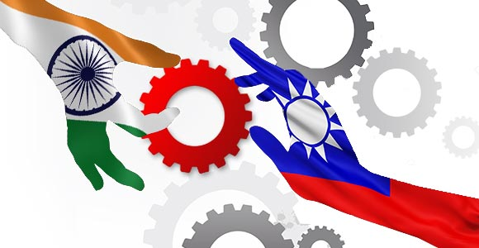

There several Indian mobile phone manufacturers like Lava, Karbonn, Micromax, Xolo, Lyf, and others. Lyf is a product from the Reliance Jio and thus it has the same marketing tactics of cheap products and discounts. All of the above Indian unicorns and companies have released various cheap copies of foreign smartphones with similar features and applications. Most of the Desi and Videshi Smartphones these days have various similarities like:

* Almost every Smartphone that is recently released carries a fingerprint match feature that was introduced in Android by Motorola initially.
* Front and back cameras are now available in all of the androids that were the feature released by Sony Corporation in their flip mobiles.
* Almost all the android mobiles have a memory of more than at least 8 GB for the storage.
* The android phones are almost similar copies of HTC’s first android release with just slight variations. Mobile storage, the preinstalled settings applications, camera features, sounds; everything displays the same type of content with just the difference in UI.

Antutu stated in a business review that 36.23 % of the copycat Smartphones imitate Samsung Galaxy. He further said that about 2.64 % of the Smartphone copies were tested on their network out of all the Smartphones. He then concluded with the fact that there are no visual differences between the copycat products and the real ones. They might also not show any vast difference with short time usage!

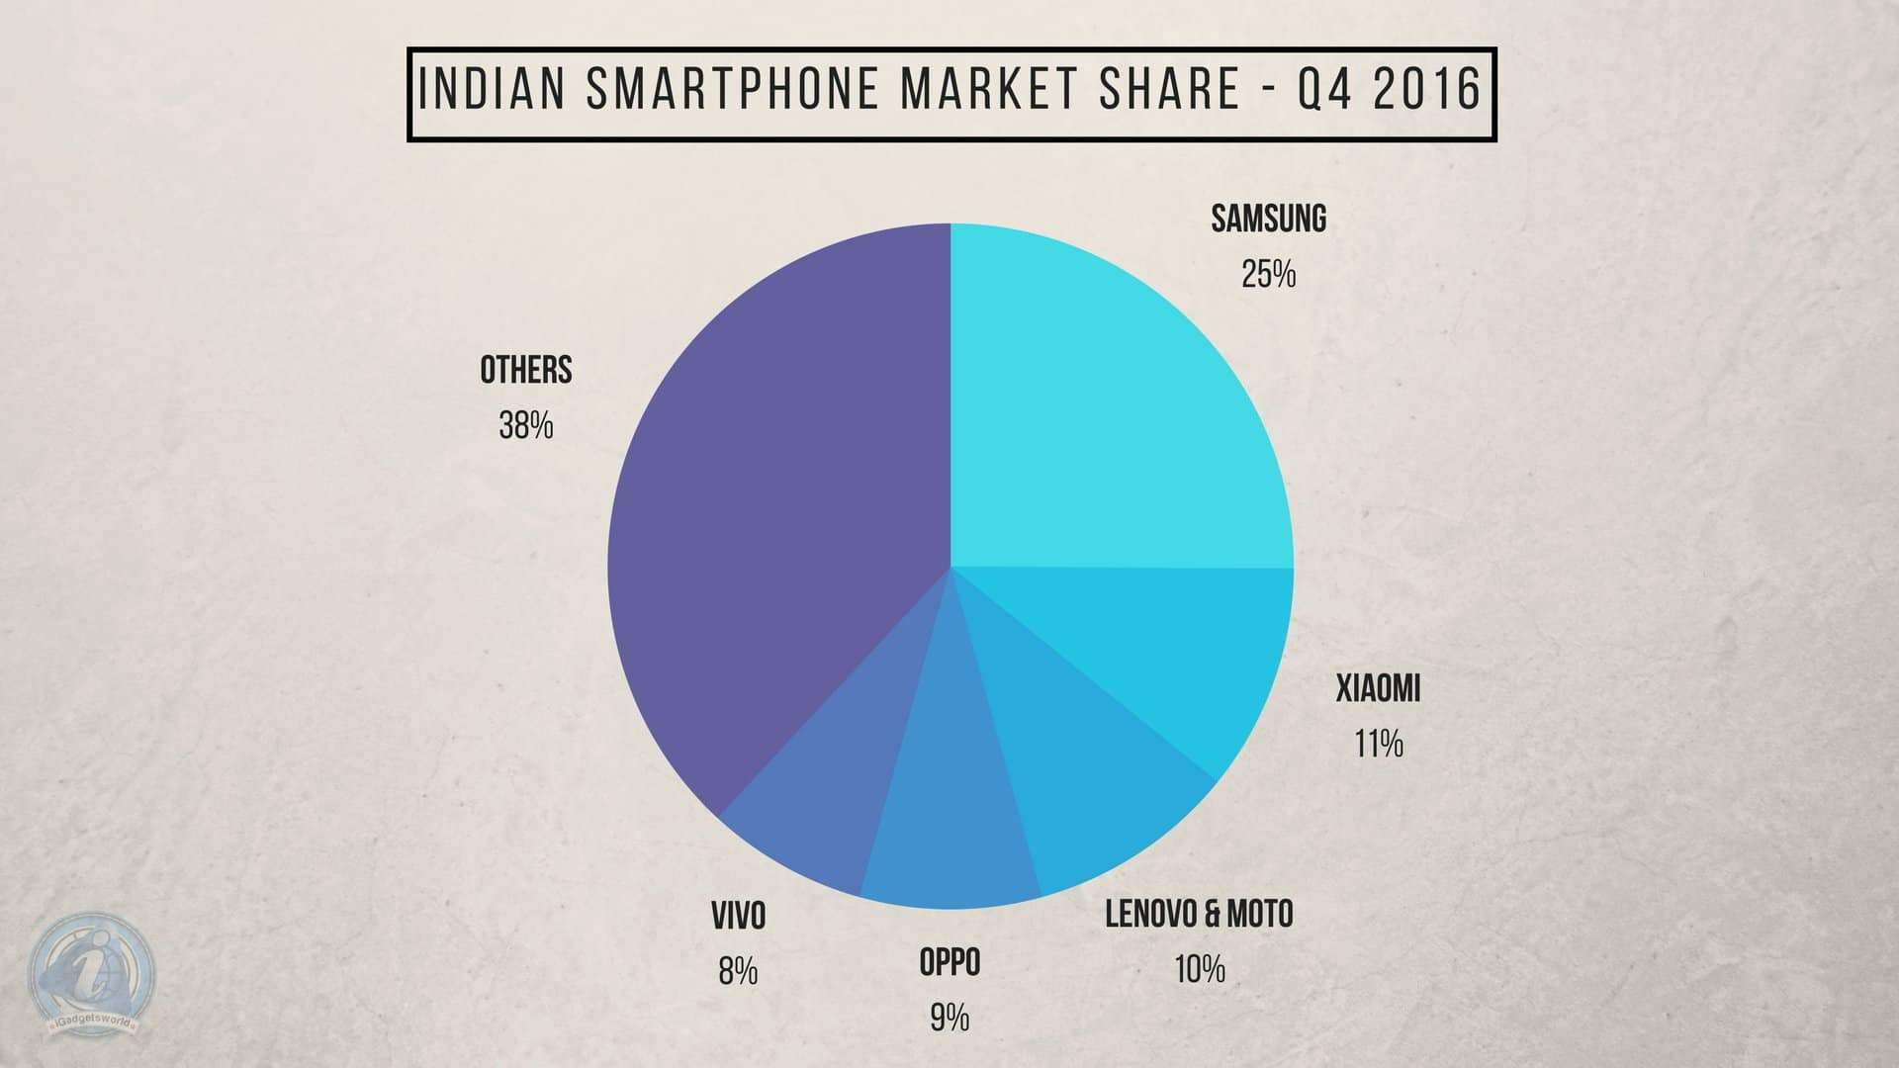

Is imitating a growth pattern for Indian manufacturers? Will Silicon Valley products be likable for the market domination of Indian copycat manufacturers?

The copycats can never compete with the parent products. And hence, even after the exact imitations, the local manufacturers are not able to beat the globally recognized manufacturers in the electronic markets. These local Smartphone publishers and manufacturers lack in various aspects like:

* Battery Backup for these Xolo, Lyf, Karbonn, and other cheap Indian Smartphones is too bad. They hardly stay functional for a few hours for the initial days after the purchase which then shows a huge downfall within a year.
* The camera quality for the imitations is very poor. They provide blurry pictures with no specified qualities. Even though the camera feature is the same, because of being cheap versions, they fail to provide higher megapixel cameras.
* Touch for these Smartphones deteriorates within a few months after the purchase. They are poorly sensitive towards the touches.
* These Desi manufacturers do not provide frequent or even timely updates in the released devices which makes their functioning poor and low with the passing time.

For the Indian Smartphone manufacturers, President Ram Nath Kovind mentioned on a press release in January 2020, that in 2014, India had only 2 mobile phone manufacturers which increased to India now being the Second Largest manufacturing Hub. There have also been various evidence on India taking tentative steps to overpower the India electronics market and the microprocessor unit sectors.

But the issue here is that all Indian manufacturers have followed the path of copying. Where is innovation? Are Indians not capable of any new achievement?

Indian manufacturers are now targeting the microprocessor chip market that is the basic necessity in any electronic device. The semiconductor chips are just the cheaper copies of the Silicon Valley’s chip and hardware market. Indian manufacturers have been successful in enticing the growing interest of the local citizens towards the “Made in India”, cheaper products!

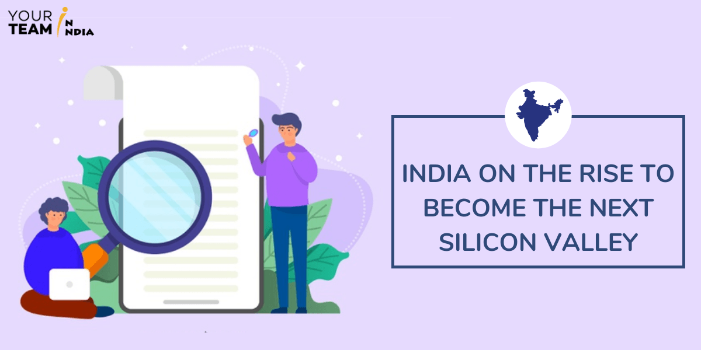

Well, India is following the same stairway of JUGAAD like China and Japan to take control of the Indian markets. First in the case of application, and now in the Smartphone industries, it is perceptible how Indian manufacturers are imitating the products of the global technology giant companies and Silicon Valley products.